Guidelines for Preparation of Thesis

– Doctor of Philosophy

A Thesis submitted by
Anand Goyal

in partial fulfillment of the requirements for the award of the degree of
Doctor of Philosophy



Indian Institute of Technology Jodhpur
Civil Engineering
October 2014
Abstract

The Doctoral Program of study requires each student to undertake research in the chosen area of study and to submit a thesis on it in consultation with the faculty member(s) supervising the same. The Doctoral Thesis is included in the curriculum with a view to synthesize the various components of the research work undertaken during the of the Doctor of Philosophy (Ph.D.) Program at IIT Jodhpur. Creating a Thesis document of the research undertaken is part of the skill building training of the student in technical communications. Here, the emphasis is on presenting a technical matter in an objective written form.

This document is a record of the mandatory guidelines to be followed while preparing the of the Ph.D. Thesis document to be submitted at the end of the Doctoral Program. It prescribes typical contents that a Ph.D. Thesis document usually should contain, and provides the format of its presentation. While most of these guidelines are prescriptive, some are subjective; but towards ensuring a relatively uniform style of presentation of all Ph.D. Theses being submitted at the Institute, these subjective guidelines are expected help in setting at least a reasonable minimum expectation of the presentation level of the work accomplished in the research program.

All students pursuing Doctor of Philosophy Program are urged to read the contents and form of this document carefully, and prepare their Ph.D. Thesis document as prescribed. It is hoped that this document will lead to a modest beginning at the Institute towards imparting education in professional written presentations.

...

Acknowledgements

I thank my Ph.D. Thesis Supervisor, Professor Samar Sharma, for introducing me to the area of technical writing and its nuances. In the process, I have learnt many technical and non-technical aspects of professional work. I am grateful to him for his help and patience as well as for constantly reminding me to be perfect in the little things that I do each day. Also, I am indebted to the Members of the Doctoral Committee, Professor Piyush Pattanayak and Professor Romendar Sikka, for their enthusiastic and continued guidance during the research work.

I thank Professor Madhava Narayan Bhatt for his classes on self-awareness, which helped me to overcome the tough times during the Doctoral Program. I thank Professor Shaik Shamsuddin for providing access to the Language Laboratory, and to the computational hardware and software facilities alongside.

My stay at the Institute was a wonderful experience because of my friends, Soumen Kundu, Madhuri Menon, Rangarajan Alagsundaram, Sateesh Eashwar and Mouni Sen, for all the liveliness they infused into the non-academic part of the days at IIT Jodhpur...

I acknowledge and thank my family, especially my sister Mohini Goyal, for the patience and love with which they ushered on me, and for bearing with me even when I was not spending less time with them. I pay respects to my parents for all their love, sacrifices and blessings…

Anand Goyal
Ph.D. Student

Contents

 |  | page
Abstract |  | I
Acknowledgements |  | iii
Contents |  | v
List of Figures |  | vii
List of Tables |  | viii
List of Symbols |  | ix
List of Abbreviations |  | x
Chapter 1: INTRODUCTION
1.1 | Purpose of this Document | 1
1.2 | Ph.D. Thesis Submission | 1
Chapter 2: Guidelines for Arrangement of Contents
2.1 | Preliminary Pages | 3
 | 2.1.1 Title Page and Front Cover | 3
 | 2.1.2 Declaration and Certificate Pages | 3
 | 2.1.3 Abstract Page | 3
 | 2.1.4 Acknowledgments Page | 3
 | 2.1.5 Contents | 4
 | 2.1.6 List of Tables and Figures | 4
 | 2.1.7 List of Symbols and Abbreviations | 4
2.2 | Main Body | 4
 | 2.2.1 Introduction | 4
 | 2.2.2 Review of Literature | 5
 | 2.2.3 Report of Outcomes of Current Study | 5
 | 2.2.4 Summary and Conclusions | 5
2.3 | Appendices | 5
2.4 | Closing Remarks | 5
Chapter 3: Specifications for Formatting the Thesis
3.1 | Preparation of Manuscript | 7
 | 3.1.1 Chapter Format | 7
3.2 | Sizes and Margins | 7
3.3 | Style of Writing | 7
3.4 | Page Numbering | 7
3.5 | Font, Line Spacing and Justification | 7
 | 3.5.1 Front Page | 8
3.6 | Equations, Tables and Figures | 8-14
3.7 | Paragraphs and Line Spacing | 15
3.8 | Symbols | 15
3.9 | References | 15
3.10 | Annexures | 16
3.11 | Publishing the Thesis | 16
 | 3.11.1 Printing | 17
 | 3.11.2 Binding | 17
 | 3.11.3 Submission | 17
Chapter 4: Summary and Conclusions
4.1 | Summary | 19
4.2 | Concluding Remarks | 19
4.3 | Closing Comments | 19
 |  | page
Annexure A : List of Structural Engineering Courses offered at IIT Jodhpur
A.1 | Courses Taught | 21
 | A.1.1 Undergraduate Courses | 21
 | A.1.2 Graduate Courses | 21
A.2 | Course Contents | 22
 | A.2.1 CE222 Structural Analysis | 22
 | A.2.2 CE251 Civil Engineering Materials | 22
 | A.2.3 CE321 Design of Steel Structures | 22
 | A.2.4 CE322 Design of Reinforced Concrete Structures | 23
 | A.2.5 CE354 Computer Aided Design and Experiments in Civil Engineering | 23
 | A.2.6 CE421 Design of Structural Systems | 23
 | A.2.7 CE422 Advanced Structural Analysis | 23
 | A.2.8 CE423 Introduction to Earthquake Engineering | 23
 | A.2.9 CE424 Structural Engineering Design Studio | 23
 | A.2.10 CE452 Principles of Construction Management | 23
 | A.2.11 CE454 Concrete Engineering | 24
References |  | 25

List of Figures

Figures | Title | page
3.1 | Overall collapse mechanisms of frame building: (a) Undesirable behaviour with plastic hinges only in one storey, and (b) Desirable behaviour with ductile plastic hinges in all beams | 11
3.2 | Diagonal compression and tension fields in an exterior RC beam-column joint (Source: Arlekar et al, 1997) | 11
3.3 | Desirable and undesirable moment-curvature relationships of beam sections | 12
3.4 | Structural Plan Density of vertical members in buildings: For the same area of vertical members (SPD), buildings tend to be more economic when structural walls are used, as against when columns of larger cross-sectional areas are used | 12
3.5 | Backbone load-displacement curves of four specimens considered in a study on structural testing of beam-column joints | 13
3.6 | Open Ground Storey Buildings in Seismic Areas – (a) A typical housing typology in practice in the urban areas of India (e.g., Chandigarh (Punjab, India)), and (b) RC Frame buildings with open ground storeys collapsed in Gandhidham (Gujarat, India) during the 2001 Bhuj (India) Earthquake | 14

List of Tables

Table | Title | page
3.1 | Quantities of Materials Required in the Designs with Different Grades of Concrete | 10

List of Symbols

Symbol | Description
A_{h} | Design Seismic Horizontal Coefficient
I | Importance Factor
R | Response Reduction Factor
S_{a}/g | Normalized Structural Response Spectral Acceleration value
V_{B} | Design Base Shear
W | Seismic Weight
Z | Seismic Zone Factor

List of Abbreviations

Abbreviation | Full form
Ph.D. | Doctor of Philosophy
PoA | Pushover Analysis

1

Introduction

The doctoral education at IIT Jodhpur is embodied with four facets, namely, (i) Course work, (ii) Independent analytical study, (iii) Experimental study, and (iv) Written and oral communication skills. Students are charged with the task of choosing the area of study and push the frontiers of that subject through research undertaken and presented in the form of a thesis. The student identifies a relatively independent question in the chosen area of study, and embarks in answering the same with the methods and skills acquired during the Ph.D. Program at IIT Jodhpur. At the end of the Ph.D. Program, the Doctor of Philosophy (Ph.D.) Thesis plays an important role of allowing synthesis of the various elements of education and breaking into new knowledge.

Writing a Ph.D. Thesis is a critical, but creative, activity of the Doctoral Program. It is a part of the training to be undergone by the Student during the Ph.D. Program. The physical presentation of the research work done determines the level of appreciation of the contention and major contribution of the research undertaken. Hence, special care is required in preparing the Ph.D. Thesis manuscript. This chapter elaborates the details that need the attention of the Ph.D. student in this effort.

1.1 PURPOSE OF THIS DOCUMENT
This document, henceforth referred to as the Guidelines, presents the general and specific requirements for the preparation of the Ph.D. Thesis. It presents guidelines for arrangement of the contents of the thesis. Detailed accounts on possible styles, structures and presentations of technical reports are available in literature [e.g., PH, 1989]. The purpose of these Guidelines is to maintain uniformity in the project reports submitted by individual students of various disciplines across IIT Jodhpur.

1.2 PH.D. THESIS SUBMISSION
For the purposes of examination and record, three copies of the report are required to be submitted to the Convener, Focus Group of the Discipline to which the student belongs. Also, the student is required to submit to the Central Library of the Institute, soft copies of the Ph.D. Thesis in WORD format. The Ph.D. Thesis Supervisor(s) are required to ensure that the guidelines as prescribed herein are adhered to by the student, while preparing the Ph.D. Thesis.

…

2

Guidelines for Arrangement of Contents

The Ph.D. Thesis consists of three parts, namely (a) preliminary pages, (b) main body, and (c) appendices. Parts (a) and (b) above are mandatory in all theses. In some Ph.D. Thesis, where vast amount of raw data is generated or used, the main body is kept brief by including only the representative and critical data derived from the raw data. And, the detailed account of the raw data can be included in the Part (c) for purposes of reference and record.

2.1 PRELIMINARY PAGES
These Guidelines have all its preliminary pages in the formats in which preliminary pages are required in the Ph.D. Thesis.

2.1.1 Title Page and Front Cover
The first page of the report is the Title Page. It contains the title of the report at the top, followed by the partial fulfillment clause, the degree for which the report is submitted, the name of the Student, the Institute logo, the name of Focus Group and Institute, and the month and year of submission. All the above shall be right justified.

2.1.2 Declaration and Certificate Pages
A declaration of academic honesty and integrity is required to be included in the Thesis. A declaration by the Ph.D. Student constitutes the next page, stating that the contents of the thesis are based on the work done by her/him, and that the same was not and will not be submitted to any other University or Institute in the world for the award of a degree. A text of the same is shown on page iii of this document.

A certification by the Ph.D. Thesis Supervisor(s) constitutes the next page, stating that the contents of the thesis are based on the work done by the student under her/his/their supervision. A text of the same is shown on page v of this document.

2.1.3 Abstract Page
The second page of the report contains the abstract of the report in a maximum of 250 words. The text should be in single spacing. The abstract shall highlight the important features of the Thesis – research work done and salient outcomes of the same. It should be complete in itself, and should not contain any citations for which the Thesis has to be referred to. Also, it should not contain any abbreviations. The abstract shall have a maximum of 250 words.

2.1.4 Acknowledgments Page
The Student may include warm acknowledgments in recognition of the support and help rendered by different persons and organisations in the conduct of the thesis. It should not exceed one page. Name of the candidate should appear at the end, without signature.

2.1.5 Table of Contents
For the ease of readily reaching the different sections of the Thesis, a complete table of contents should be included indicating the sections and the corresponding page numbers. The “Contents” shall follow the “Acknowledgements” and shall list the titles of the Chapters, Sections and Subsections using decimal notation, as in the text, with corresponding page number against them, flushed to the right.

2.1.6 List of Tables and Figures
For quick access to the tables referred to in the text, a list of tables and figures is essential. These lists are made on separate pages and should follow the Table of Contents page. Each list shall have number and captions of the Table/Figure along with the corresponding page number flushed to the right. The space between the text and the page number shall not be filled with any dots or dashes.

2.1.7 List of Symbols and Abbreviations
The symbols and notations (with subscripts and superscripts) used in the body of the text are defined in detail on the first instance of their occurrence. Also, a list of the brief definitions of all symbols should be included for easy comprehension of the thesis; should the symbols appear at a location far away from where it has been defined first, this list will be a great help. Some symbols appearing in this manual and their brief definitions are presented in the List of Symbols on page x. As shown, the English alphabet based symbols appear first (with capitals ahead of the lower case symbols) and then the Greek alphabet based symbols (again with capitals ahead of the lower case symbols).

Also, a complete list of all abbreviations shall be provided after the list of symbols. The abbreviations should be expanded in full. The list shall be prepared in the alphabetic order.

2.2 MAIN BODY
The Student must present the content of the Ph.D. Thesis in the main body of the text. In general, it may contain the following relatively independent Chapters:
(1) Introduction of the subject matter of the thesis,
(2) Review of literature published on the past work in the area of study to bring out the status of the work done – problems, issues involved and gap areas; and relevance, motivation and objectives of the present work,
(3) Analytical work – testing of the analytical model, and analysis and discussion of analytical work,
(4) Experimental work – analysis, design and conduct of the experimental study, analysis and discussion of experimental data, and validation of analytical model,
(5) Summary, conclusions, and recommendations for future work, if applicable.
Any past work quoted in the report shall be properly cited. And, a list of all references cited in the report shall be provided at the end of the main text of the report, in a different section.

2.2.1 Introduction
Chapter 1 titled Introduction, shall introduce the subject matter of the Thesis to the reader. The primary intent of this Chapter is to highlight the problem studied, and explain the objective and scope of the research work presented in the Thesis.

2.2.2 Review of Literature
Chapter 2 titled Review of Literature, shall present a critical analysis of the previous work published in the public domain pertaining to the subject matter of study. Review shall be presented topic-wise and not author-wise. The key outcome of this Chapter is the list of gap areas identified in the current understanding of the subject matter in focus in the present study, and the scope of work identified for the current study.

2.2.3 Report of Outcomes of Current Study
The entire new work undertaken by the student in terms of analytical and experimental work shall be presented in a logical manner, in a limited number of chapters, each with an appropriate chapter title. In doing so, the following shall be kept in mind:
(1) Detailed account shall be presented of the analytical study. Important derivations should be presented in the text of these chapters; extensive and long treatments, copious details and tedious information, detailed results in tabular and graphical forms shall be presented in Annexures. Representative data in table and figures may be included in appropriate chapters;
(2) Full details shall be presented of the experimental study, namely the test setup, procedures adopted, techniques developed, and methodologies adopted;
(3) Figures and tables should be presented immediately following their first mention in the text. Short tables and figures (spanning less than half the writing area of the page) should be presented within the text, while large tables and figures may be presented on separate pages.
(4) Equations should form separate lines with appropriate paragraph separation above and below the equation line, with equation numbers flushed to the right.
(5) The analyses of the results obtained from the analytical and experimental studies should be presented at the end of the corresponding Chapters. The discussion of these results shall logically lead to inferences and conclusions, as well as to scope for possible further future work.

2.2.4 Summary and Conclusions
This forms the last chapter of the Thesis, and shall bring out the salient work done as part of the present study along with the major conclusions drawn from the same. While small and detailed observations would be recounted at the end of the respective Chapters mentioned in Section 2.2.4, the emphasis of this Chapter is the global increments in knowledge generated out of the present study. No new conclusions shall be drawn here; only those drawn in the previous Chapters shall be recounted.

2.3 APPENDICES
The appendices play an important role of record keeping of the valuable data gathered for and during the project. The appendices may contain different types of data, e.g., questionnaire and survey forms, raw experimental data, raw analytical data, drawings, computer program listings, and detailed derivations of certain expressions used in the main body of the report.

2.4 CLOSING REMARKS
These Guidelines give only basic requirements for preparing the Ph.D. Thesis. In addition to points mentioned in this document, the Ph.D. Thesis should be easy to read and pleasant in appearance. Several aspects of report writing, e.g., style of writing and presentation, are not discussed in these Guidelines. Guidance may be obtained from standard literature on the subject matter of the report.
…

3

Specifications for Formatting the Thesis

In general, the theses submitted by the students of the Institute must bear a uniform style and format; even within a report, adopting an identical style and format throughout the thesis, will lead to an easily readable document. The specifications mentioned in this chapter are mandatory in the preparation of the thesis; students shall adopt these without fail.

3.1 PREPARATION OF MANUSCRIPT
The Thesis shall be typeset completely on any electronic medium with uniform sized and spaced characters, lines and margins on every page. Microsoft Word software shall be used for preparing the Thesis. The Thesis shall be free from typographical and grammatical errors, and from any hand-written scripts. The “spell-check” facility available with the word processors should be utilized for this purpose. The use of tape as an adhesive is not permitted. All photographs shall be pasted with a good quality adhesive applied at the back side of the photographs, and not on them.

The font used shall be “Book Antiqua” for the entire text in the body of the Thesis. The font style shall be “Candara” for the text of the headings of the sections, and of the titles of all tables and figures. Also, the font style shall be “Candara” inside the tables and figures. The said font style shall be applicable for the appendices also. Footnotes shall not be used in the preparation of the Thesis.

The matter shall be printed on good quality white sheets by laser printers. The pages shall be printed back to back. Hence, care must be taken to ensure that the paper quality is not too translucent to show the material on the backside. Mirror margins shall be used to ensure same distance of the leading and finishing text from the edges of all pages.

All copies of the Thesis shall be clear, adequately dark and even. Again, when pages are photocopied back to back, care must be taken to ensure that the paper quality is not too translucent to show the material on the backside.

3.1.1 Chapter Format
The Thesis shall be organised into relatively independent Chapters. Each chapter shall have a precise title reflecting the contents of that Chapter. Further, each Chapter shall be organized into Sections and Sub-Sections so as to present the content discretely and with due emphasis and clarity. Each chapter shall begin on a fresh “odd” page. Chapter number (in Arabic) shall appear as right justified at the top of the page in Candara 27 pts in italics face, and title using first letter capitals. No vertical gap shall be left between Chapter number and Chapter title. A gap of 5 lines (of 11pt thickness) should be used between Chapter heading and first paragraph.

A chapter can be divided into Sections, Subsections and Sub-subsections so as to present different concepts separately. Sections and subsections can be numbered using decimal, e.g., 2.2 for the second section in Chapter 2 and 2.3.4 for the fourth subsection in third Section of Chapter 2. The Sub-subsections shall be numbered as “(a)”, “(b)”, …. No further sub-sectioning shall be done beyond this third level. Chapters, Sections and Subsections shall be included in the contents with page numbers flushed to the right; the inner subsections shall not be included in the contents.

3.2 SIZES AND MARGINS
The finished size of the Thesis shall be that of an A4 page, i.e., 210mm×297mm (8.27” × 11.69”). The total number of pages of the Thesis shall not exceed 200. The margins at the top, bottom and outside shall be 12.5mm (½”), while that in the inside shall be 32mm (1.27”). These limits are applicable for the entire Thesis. The Header and the Footer shall be at 12.5mm (½”) and 11.25mm (0.4”), respectively.

Any sub-section started near the bottom of the page, shall have at least four lines of text following it on that page; else, it must be started on the next page by placing a few blank lines preceding the sub-section.

3.3 STYLE OF WRITING
All text shall be cast in third person singular. The sentences shall be kept in passive voice. Only fact shall be presented in the thesis; personal opinions, thoughts and feelings shall not be included in the Thesis, irrespective their possible validity, importance and correctness.

3.4 PAGE NUMBERING
The Thesis shall be printed on back to back pages. Beginning with the first page of Chapter 1, all pages of the report including the appendices shall be numbered sequentially in Arabic numerals, e.g., 1, 2, 3, ... The pages preceding Chapter 1, which are referred to as the preliminary pages, shall be numbered in lower case Roman numerals, e.g., i, ii, iii, ... In this regard, the title page (the first page inside the front cover) is considered to be having number i; but, this number is not printed on the title page. Chapter 2 and other Chapters shall start on the “odd” page.

All page numbers shall be placed in the center of the page in the footer area at the bottom the page; the number shall be center justified to the available footer text area on all pages, odd or even. The font type for page number shall be same as that on the other pages of the Thesis, i.e., “Candara”. But, the font size shall be 10pt and in bold style.

3.5 FONT, LINE SPACING AND JUSTIFICATION
The font shall be “Candara” for all text on front page. The font size in the whole report is 11pt for all text in the preliminary, main and appendices pages. Some text in the tables and the figures may have smaller fonts, but not smaller than 8pt. But, the titles of the tables and figures shall be in 12pt. The line with chapter number shall be in 27pt italics and that with the chapter title in 18pt, bold style.

All section headings shall be left justified. First level sub-headings shall be in 13pt, bold style with all capitals. The second level sub-headings shall be in 12pt, bold style, and the third level sub-headings in 11pt, bold italics style. In the chapter titles, headings and sub-headings, where first letters are in capitals, words, such as “of”, "a", "an" and "the", shall be in lower case.

All text in the report shall be in single spacing with each line 11pt thick. One blank line of 11pt size is provided after every paragraph. Before every first level heading, two blank lines are provided each of 11pt size, and before every first and second level sub-headings, one blank line of 11pt size. No space shall be left between the headings and sub-headings and the text that follows them. Between the line having the chapter title and the text that follows, four blank lines shall be provided of 11pt size. The entire text shall be double justified to the width of the available textbox after removing the margins.

3.5.1 Front Page
The front cover of the bound copy should be the same as the title page of the Thesis. All text on the front cover should be right justified. The font size and style to be used on the Title Page are different for different lines. The title of the report at the top of the page will be in 23pt, bold style. The full name of the student shall be shown in 18pt, bold style with first letters in capitals, and regular font style. The partial fulfillment clause is in 14pt, italics style. The degree for which the report is submitted is in 18pt, bold capital style.

This shall be followed by the high resolution image of the Institute logo at the bottom of the page. The font size shall be 14pt for name of Focus Group to which the student is affiliated (in bold font style), the name of Institute to which the Thesis is submitted (in bold capital font style), and the month and year of submission (in regular font style). The line spaces between the above items shall be 5 lines of 12pt regular font between the title and name of student, and between name of student and name of degree group as shown in this document.

3.6 EQUATIONS, TABLES AND FIGURES
All equations, tables and figures shall be prepared on electronic media. All tables (tabulated data) and figures (charts, graphs, maps, images, diagrams, etc.) should be presented in portrait orientation, to the extent possible.

Equations shall be embedded in the text at the appropriate locations. Equations shall be placed with one tab from the left margin of the active text. Each equation shall be assigned a number, which is placed in right end of the line in parentheses. For example, in civil engineering, Indian seismic design code IS:1893(1) allows the regular buildings with height lesser than 40m, to be designed by the Equivalent Static Procedure, in which the design lateral force is estimated as a fraction (called Design Seismic Horizontal Coefficient A_{h}) of the seismic weight of the building. Factors that govern A_{h}, include seismic zone, local soil type, importance of building, and structural system adopted. These factors are discussed in this section. The design lateral force (also called Design Base Shear) V_{B} of a building is given by:
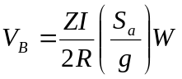, (3.1)
where Z is the Seismic Zone Factor, I the Importance Factor, R the Response Reduction Factor, 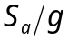 the normalized Structural Response Spectral Acceleration value and W the Seismic Weight of the building. Design base shear value is used commonly to normalize the ordinates of the load-deformation curve generated from Pushover Analysis (PoA).

Tables are placed immediately following the paragraph in which their reference is made, with three lines in between each of 11pt thickness. Between two consecutive tables or two consecutive figures, three single line spaces shall be provided (each of 11pt thickness). All tables bear a number and a caption; the number and caption of a table precede a table. One line space (of 11pt thickness) shall be provided between the table caption and the table itself. If there is not much place in that page to accommodate the table, it must appear at the top of the next immediate page. Table 3.1 demonstrates this; the table lists the quantities of material used in structural elements of a building when different grades of concrete are used.
Table 3.1 : Quantities of Materials used in Structural Elements with Different Grades of Concrete

Members | Quantities of Materials
Members | Steel (kg) |  |  | Concrete (m³)
Members | M20 | M25 | M30 | M20 | M25 | M30
Slabs | 4,632 | 4,632 | 4,632 | 145.7 | 145.7 | 145.7
Beams | 22,137 | 21,980 | 21,980 | 104.1 | 104.1 | 145.7
Columns | 16,485 | 16,014 | 15,622 | 89.1 | 89.2 | 89.2
Footings | 8,871 | 8,557 | 9,420 | 133.9 | 126.0 | 118.2

Hand drawn figures are not acceptable. All figures shall be electronically generated only. Just as the tables, figures also shall be placed immediately following the paragraph in which their reference is made. While representing figures, good quality line drawings/figures must be drawn using standard software that provides vector rather than bitmap graphics; and these figures must be scalable.

All figures shall bear a caption placed below the figure; there shall be a single line (11pt) space in between the figure and its caption. Please see Figures 3.1 to 3.6 as a demonstration of the same. Again, if there is not much place in that page to accommodate the figure, it must appear at the top (or after a table there, if any) of the next immediate page.

Images, photographs, etc., must be scanned in resolution exceeding 200dpi with 256 grayscales for monochrome images and 24 bit per pixel in case of colour images. When Photographs used in figures shall be securely pasted on the page using good quality photo-mounting cement applied at the back side of the photo. Mounting corners, tape or staples are not allowed.

The title of the tables and captions of figures shall be in 10pt, in regular style, except the word “Table” and “Figure” and the numbers of the table and figure, respectively, which shall be in bold. The text of the title of tables and captions of figures are double justified. The first letters the principal words (i.e., nouns, pronouns, verbs, adverb, and adjectives) shall be in capitals.

All equations, tables and figures are numbered chapter-wise in Arabic numerals. They are numbered sequentially in the order of their first appearance. The first Equation, Table and Figure of Chapter 3 shall be referred to as Eq.(3.1), Table 3.1 and Figure 3.1, respectively. Tables and figures reproduced from elsewhere shall be cited at the last with a separate line in the table and figure caption stating “(Source: Arlekar et al, 1997)”.

Small displacement
at collapse
All damage in one storey
Damage distributed in all storeys
Large displacement at collapse
Damage

(a) (b)

Figure 3.1 : Overall collapse mechanisms of frame building: (a) Undesirable behaviour with plastic hinges only in one storey, and (b) Desirable behaviour with ductile plastic hinges in all beams

C
C
T
Column
Beam
T
Beam-Column Joint

Figure 3.2 : Diagonal compression and tension fields in an exterior RC beam-column joint (Source: Arlekar et al, 1997)

M
φ
M_{demand}
φ_{Min}
Sufficient strength
Inadequate ductility
Inadequate strength
Inadequate ductility
Good strength Unrealizable ductility
φ_{usable}
Good strength Reasonable Ductility
Reasonable Ductility Range

Figure 3.3 : Desirable and undesirable moment-curvature relationships of beam sections

Structural Plan Density (%)
Moment in Interior Column (kNm)
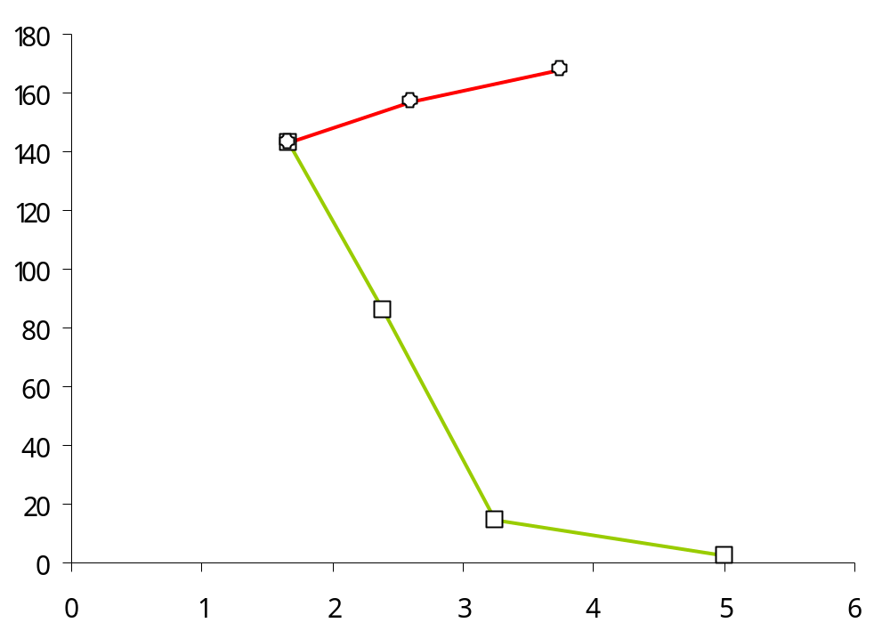

Figure 3.4 : Structural Plan Density of vertical members in buildings: For the same area of vertical members (SPD), buildings tend to be more economic when structural walls are used, as against when columns of larger cross-sectional areas are used

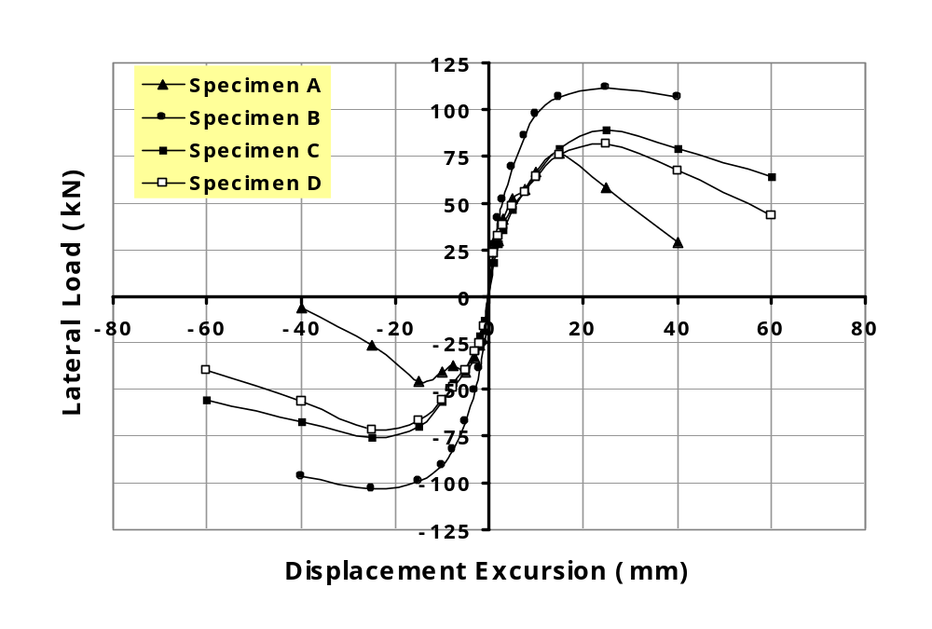

Figure 3.5 : Backbone load-displacement curves of four specimens considered in a study on structural testing of beam-column joints

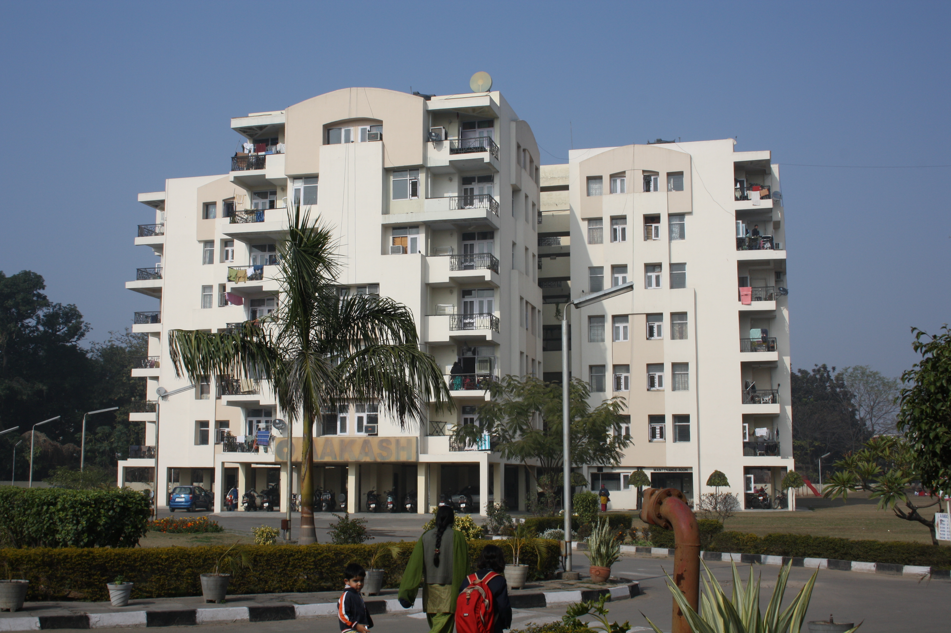
(a)

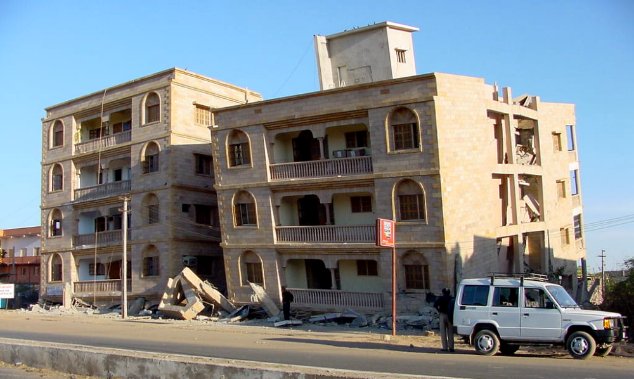
(b)

Figure 3.6 : Open Ground Storey Buildings in Seismic Areas – (a) A typical housing typology in practice in the urban areas of India (e.g., Chandigarh (Punjab, India)), and (b) RC Frame buildings with open ground storeys collapsed in Gandhidham (Gujarat, India) during the 2001 Bhuj (India) Earthquake
3.7 PARAGRAPHS AND LINE SPACING
The running text has to be paragraphed in single line spacing. The vertical space between paragraphs shall be single line spacing. The first line of each paragraph should normally be indented by 12.5mm (½“). A paragraph should comprise more than one line. A single line of a paragraph shall not be left at the top or bottom of a page (i.e., no windows or orphans should be left). No word should be hyphenated at the right end of the first line of a page or paragraph.

3.8 SYMBOLS
All symbols used in the text shall be listed alphabetically and defined in the List of Symbols in the preliminary pages of the report. First, all the uppercase symbols shall be listed, then lowercase symbols, and finally the Greek symbols (in the Greek alphabetical order).

3.9 REFERENCES
All formal literature used in the research shall be referred to at the appropriate locations in the text. Referencing shall be consistently adopted thorough the thesis. Standard citation style should be followed as demonstrated in this document in the “References” at the end of these Guidelines. No reference shall be made in the Thesis to personal communications. The references shall be presented in 10pt size and in “Book Antiqua” regular font. All pertinent works of literature should be cited, if used in the Thesis; no ‘Bibliography” should be provided.

While citing the references, they shall be placed in square brackets consists of last name followed by a comma and the year of publication of that reference. This reference shall be placed at the appropriate location in the sentence, but before the full stop. For example, the text presented in this document is derived from two other documents available [IITK, 1982; IOE, 1999].

When there are two authors, the last name of the first author is followed by an "and" and the last name of the second author; this is then followed by a comma and the year of publication [e.g., Paulay and Priestly, 1992]. When the number of authors is more than two, the citation has the last name the first author followed by "et al”, a comma and the year of publication [e.g., Arlekar et al, 1997]. But, the entire list of authors is provided in the reference included in the list of References. The formats are different for referring to research papers [e.g., Jain and Navin, 1995], design codes [e.g., IS:456, 1984], text books [e.g., Paulay and Priestley, 1992] and computer programs [e.g., CSI, 1999]. Citation from websites should include the names(s) of author(s) (including the initials), full title of the article, website reference and when last accessed, e.g., the website of IIT Jodhpur [IITJ, 2014]. A sample style of referencing is given in the two paragraphs below:

“More than 60% of India's land area is considered to be prone to earthquakes of intensity VII and above (in MMI scale). Some of the largest earthquakes in the recorded past have occurred in Indian subcontinent which includes Assam earthquake of 1897 (M8.7), Kangra earthquake of 1905 (M8.6), Bihar Nepal earthquake of 1934 (M8.4), Assam-Tibet earthquake of 1950 (M8.7) and the list goes on [Jain, 1998]. The descriptions of 1897 Assam earthquake provided the highest grade, XII, of the MMI Scale. Because of this high seismic activity, development of seismic zone maps and guidelines about earthquake resistant features started as early as 1930’s [Jain and Nigam, 2000]. Despite such early developments, extensive damage was observed even during recent moderate earthquakes, e.g., 2006 Sikkim earthquake and 2011 Sikkim earthquake [Kaushik et al., 2006; Murty et al., 2011], because earthquake safety is overlooked in India. Since frequencies of occurrence are simply statistical probabilities, one or more earthquakes could occur in a much shorter period than the average return period. With the current knowledge, there is no practical alternative for designing structures located in earthquake-prone regions other than assuming that the design earthquake specified in the building codes could occur at any time [FEMA 577, 2007].

Most constructions in India are with reinforced concrete (RC), which is governed by two design codes, namely IS:456 [IS:456, 2000] and IS:13920 [IS:13920, 2007]. IS:456 gives design specifications for general RC buildings and IS:13920 for earthquake-resistant RC buildings. There is a widespread notion that use of high strength steel and cement will result in 'earthquake proof' buildings. Though high quality materials are essential, unless they are used in right amounts, at right places and of known strengths, a good seismic behaviour cannot be achieved even in designed buildings. For example, HYSD bars confirming to IS:1876 [IS:1876, 2008] have a strain capacity of more than 0.145, all of it cannot be utilised in RC beams [Diwaker, 2009] owing to choices of beam cross-section size, grade of concrete and amount of compression longitudinal steel. But, design provisions given IS:13920 in association with those in IS:456 have not been investigated, either analytically or experimentally, from the point of view of achieving high sectional ductility.”

The list of references is arranged in alphabetical order as shown in the list of References at the end of Guidelines. All references shall be in single spacing with second and subsequent lines indented forward by ¼ inch. Only those references cited in text shall be included in the list of references.

3.10 ANNEXURES
Detailed information shall be placed in an Annexure, which is too lengthy to be included in the text or which is not immediately essential to an understanding of the subject. Lengthy derivations, original data, raw experimental observations, supplementary illustrative material, etc., shall be presented in the separate appendices. Likewise, tables, figures, etc., contained in the Annexures should be included in the lists of tables and figures, respectively. Since references can be made to literature in the Annexure, the Annexures shall precede the List of References.

Each annexure shall be started on a fresh odd page. Each annexure shall be identified by capital letters of English alphabet in the sequence of their appearance. The sections and sub-sections in the Annexures shall be numbered with the first letter being that of the English alphabet corresponding to that annexure. Please see Annexure A for example. Each Annexure should be listed separately with its title in the Table of Contents.

All guidelines applicable for the main text of the thesis shall be applicable to Annexures too. When Annexures make the report voluminous, they may be printed in reduced font size to limit the size of the report; in such cases, the font size shall not be smaller than 8pt.

3.11 PUBLISHING THE THESIS
Three aspects are involved in the publishing of the Thesis, namely Printing, Binding and Submission. Details of these three aspects are presented in the sub-sections below. But, before all these can be done, the Thesis should be scanned for the presence of any potentially plagiarised content, through the anti-plagiarism software licensed by the Institute.

3.11.1 Printing
The white bond paper shall be used. The quality of the paper used should meet the following specifications, namely (a) White bond paper with whiteness 95% or more, and (b) Weight of at least 80g/m². The quality of paper used should be the same throughout. Photographs or images shall be printed on the same paper; no glossy paper shall be used. The front cover of the bound volume bears the same material as the Title Page of the report. Additional white sheets shall be inserted as per requirement for binding. One blank white sheet shall be inserted one at the beginning and another at the end of the Thesis. Printing of hard copies shall be in black for text and colour for images (if necessary) using a laser printer.

3.11.2 Binding
The Thesis should be presented in a single volume; multi-part or multi-volume Thesis is not allowed. The cover of the hard bound copies of the Thesis submitted after the oral defence examination of the Ph.D. Thesis, shall be in Maroon colour. The following matter shall be placed on the hard bound cover of the Thesis along its bound spine: Student name, Thesis title (abbreviated, if required), Degree name, Focus Group (abbreviated), and year of graduation (in YYYY format). All lettering on front cover and spine shall be embossed in Golden colour.

3.11.3 Submission
Thesis shall be submitted in both hard copy and electronic versions. Details of these versions to be submitted to the Office of Academics of the Institute, shall be guided by the requirements given in the sub-sections below.

(a) Hard Copy
The three hard bound copies of the thesis shall be submitted after the final defense for archiving in the Library of the Institute. The final hard copies submitted must have incorporated all corrections (if any) suggested by the Examiners; the same should be certified by the Supervisor(s) in a cover letter accompanying the final versions of the Thesis.

The Thesis should be printed or photocopied on both sides of white paper. All copies of Thesis pages must be clear, sharp and even, with uniform size and uniformly spaced characters, lines and margins on every page.

(b) Electronic Copy
An electronic copy of the final corrected version of the Thesis should be submitted to the Library of the Institute. This electronic version should be a DVD, clearly labeled with Student’s Name, Roll Number, Title of the Thesis, and Date of Submission. The DVD should have all WORD files, single PDF of the FULL thesis, any animation files, and image files of all Figures, Photos, etc., used the Thesis.

…

4

Summary and Conclusions

This is the last chapter of the Thesis. Usually, this chapter is brief, with precise statements that summarise and conclude the Thesis. A brief recall of the research work carried out shall form the first part of this Chapter. Conclusions derived from the logical analysis presented next. Finally, scope for future work shall be stated lucidly.

4.1 SUMMARY
This section summarises the work accomplished in the Thesis work in point-wise way. It has the objective of the study undertaken, the methodology adopted and the work accomplished. The above items are concisely described here in an itemized way; details are not provided.

4.2 CONCLUDING REMARKS
The Ph.D. Thesis is a written record of the research work undertaken, the outcomes of the research are expected to heave significant bearing on the state-of-the-art or state-of-the-practice. Concluding remarks on the salient outcomes of the research work shall be recapitulated in this section in point-wise way. If there are specific recommendations for future work in the subject matter discussed as a consequence of the outcomes of this research work, the same may be made here in a new paragraph.

4.3 CLOSING COMMENTS
While due care has been taken in preparing these guidelines, it provides only the basic requirements for preparing the Ph.D. Theses. Besides the points mentioned in these Guidelines, a Thesis should be reader-friendly in both its appearance and presentation. Aspects, such as style of writing, language usage and presentation, have been just mentioned, but not discussed in depth. Formal language should be followed in writing the Thesis, ensuring that the expression style adopted as a practice in standard literature of the discipline in which research is undertaken. Notwithstanding the above, the style and format followed in writing must be uniform and homogenous throughout the Thesis, including in (a) citing references; (b) using dimensions, units and notations; and (c) preparation of tables, figures and equations.

…

Annexure A

List of Structural Engineering Courses

offered at IIT Jodhpur

Structural Engineering is one of the major streams of study in the Department of Civil Engineering at IIT Jodhpur. The stream deals with the designing and constructing the built environment. Most basic courses are taught at the undergraduate level. And, advanced level courses that reflect the competence of faculty members currently employed at the Institute and who are formally trained to conduct research in Structural Engineering, are offered at the post-graduate level.

A.1 COURSES TAUGHT
Undergraduate education in the Department of Civil Engineering at IIT Jodhpur has a strong component of courses in structural engineering. Also, the undergraduate students have the option of crediting as electives some of the advanced courses offered to students of the post-graduate program in structural engineering. These courses are listed in the sub-sections below.

A.1.1 Undergraduate Courses
The undergraduate courses offered in the stream of Structural Engineering are categorised into two sets, namely compulsory and electives. These are listed in the sub-sections below.

(a) Compulsory Courses
The compulsory courses of the B.Tech. (Civil Engineering) Program are:
(1) CE 222 : Structural Analysis
(2) CE 251 : Construction Materials
(3) CE 321 : Design of Steel Structures
(4) CE 322 : Design of Reinforced Concrete Structures

(b) Elective Courses
The elective courses of the B.Tech. (Civil Engineering) Program are:
(1) CE 354 : Computer Aided Design in Civil Engineering
(2) CE 421 : Structural Design III
(3) CE 422 : Advanced Structural Mechanics
(4) CE 423 : Introduction to Earthquake Engineering
(5) CE 424 : Special Topics In Structural Design
(6) CE 452 : Principles of Construction Management
(7) CE 454 : Concrete Engineering

A.1.2 Graduate Courses
The post-graduate courses offered in the stream of Structural Engineering also are categorised into two sets, namely compulsory and electives. These are listed in the sections below.
(a) Compulsory Courses
The compulsory courses of the B.Tech. (Civil Engineering) Program are:
(1) CE620 : Structural Dynamics
(2) CE621 : Advanced Structural Analysis
(3) CE622 : Theory of Plates and Shells
(4) CE722 : Structural Mechanics and Stability

(b) Elective Courses
The elective courses of the B.Tech. (Civil Engineering) Program are:
(1) CE 625 : Advanced Design of Masonry Structures
(2) CE 626 : Advanced Design of Reinforced Concrete Structures
(3) CE 629 : Earthquake Analysis & Design of Structures
(4) CE 721 : Random Vibrations
(5) CE 723 : Durability of Concrete Structures
(6) CE 724 : Advanced Design of Steel Structures

A.2 COURSE CONTENTS
A brief of the contents of the courses in Civil Engineering at IIT Jodhpur are reviewed about once every five years. Changes can be made even more frequently, if there are clear proposals from faculty members teaching the courses. A brief account of the contents of undergraduate courses mentioned above is given in the sections below.

A.2.1 CE222 Structural Analysis
Credit Structure L-T-P [C] :: 3-1-0 [4]
Introduction to Structural Analysis
Analysis of Statically Determinate Structures
Moving loads
Analysis of Statically Indeterminate Structures

A.2.2 CE251 Civil Engineering Materials
Credit Structure L-T-P [C] :: 3-0-3 [4]
Engineering Properties of CE Materials
Concrete
Steel
Masonry
Bituminous Mixes
Other CE Materials

A.2.3 CE321 Design of Steel Structures
Credit Structure L-T-P [C] :: 3-1-0 [4]
Introduction to Steel and Steel Structures
Introduction to Design of Steel Structures
Working Stress Design of Structural Components
Working Stress Design of Connections
Plastic Design

A.2.4 CE322 Design of Reinforced Concrete Structures
Credit Structure L-T-P [C] :: 3-1-0 [4]
Introduction to Concrete Structures
Introduction to Design of Reinforced Concrete Structures
Working Stress Design of Structural Components
Limit State Design of Structural Components
Capacity Design Concepts

A.2.5 CE354 Computer Aided Design and Experiments in Civil Engineering
Credit Structure L-T-P [C] :: 3-0-3 [4]
Automation in Design
Automation in Experiments
Automation in Computations

A.2.6 CE421 Design of Structural Systems
Credit Structure L-T-P [C] :: 3-0-0 [3]
Design of Prestressed Concrete Structures
Design of Masonry Structures
Design of RC Elevated Water Tanks
Design of Bridges

A.2.7 CE422 Advanced Structural Analysis
Credit Structure L-T-P [C] :: 3-0-0 [3]
Matrix Methods of Structural Analysis
Introduction to Dynamics of Structures

A.2.8 CE423 Introduction to Earthquake Engineering
Credit Structure L-T-P [C] :: 3-0-0 [3]
Physics of Earthquakes
Structural Response
Philosophy of Earthquake Resistant Design
Earthquake, Resistant Design and Construction
Structural Control

A.2.9 CE424 Structural Engineering Design Studio
Credit Structure L-T-P [C] :: 3-0-0 [3]
Structural Analysis, Design, Detailing and Construction Drawing of 3 of the following:
(1) Multi-storey RC Frame Buildings
(2) Steel Antenna/HT Open Web Towers
(3) Railway/Highway Bridge
(4) Elevated Water Tank
(5) Multi-Storey Reinforced Masonry Building
(6) RC Chimney

A.2.10 CE452 Principles of Construction Management
Credit Structure L-T-P [C] :: 3-0-0 [3]
Introduction to Construction Equipments and Their Use
Introduction to Construction Management
Financial and Economic Issues
Contract Management
Interdisciplinary Nature of Modern Construction
Case Studies

A.2.11 CE454 Concrete Engineering
Credit Structure L-T-P [C] :: 2-0-3 [3]
Review of properties of fresh and hardened concrete
Fundamental Concrete Science
Special concretes
Special construction methods with Concrete
Special Reinforcing Materials
Case studies (Laboratory studies)

…

References

A615/A615M-12, (2012), Standard Specification for Deformed and Plain Carbon-Steel Bars for Concrete Reinforcement, American Society for Testing and Materials, USA
ACI 318, (1999), Building Code Requirements for Structural Concrete and Commentary, American Concrete Institute, Farmington Hills, Michigan, USA
Agussalim, B.H., (2004), "Effect of Compression Reinforcement Arrangement on Ductility of Reinforced Concrete Beams", 29th Conference on Our World in Concrete & Structures, 25 - 26 August 2004, Singapore
Arlekar,J.N., Jain,S.K., and Murty,C.V.R, (1997), “Seismic Response of RC Frame Buildings with Soft First Storey,” Proceedings of the CBRI Golden Jubilee Conference on Natural Hazards in Urban Habitat, 10-11 November 1997, New Delhi, pp 13-24, Tata McGraw Hill Publishing Company Limited, New Delhi
Basu,P.C., Shylamoni,P., and Roshan,A.D., (2004), “Characterisation of steel reinforcement for RC structures: An overview and related issues”, Indian Concrete Journal, Vol. 78, No. 1, pp.19-30, January 2004
CSI, (1999), SAP2000 Integrated Finite Element Analysis and Design of Structures, Users Manuals, Computer and Structures Inc., Berkeley, California, USA
Deierlein,G.G., Reinhorn,A.M. and Willford,M.R., Nonlinear Structural Analysis for Seismic Design: A Guide for Practicing Engineers, NEHRP Seismic Design Technical Brief No.4, National Institute of Standards and Technology, U.S. Department of Commerce, Gaithersburg, October 2010
Derecho,A., and Kianoush,M.R., (2001), “Seismic Design Of Reinforced Concrete Structures”, Seismic Design Handbook, 2nd Edition, Edited by Farzad Naeim, Kluvier Academic Publishers, pp 463-562, 2001
Desayi,P. and Krishnan,S., (1964), "Equation for the stress-strain curve of concrete", ACI Journal, Proceedings, Vol.61, March 1964, pp.345-350
IITK, (1982), "THESIS GUIDE: Specifications and Guidelines Regarding Thesis Preparation," Post-Graduate Office, Indian Institute of Technology Kanpur, India
IITJ, (2014), www.iitj.ac.in/academics; 05 October 2014
IOE, (1999), “Guidelines for the Preparation of Final Year Project Report,” Department of Mechanical Engineering, Institute of Engineering (Pulchowk Campus), Tribhuvan University, Nepal
IS:456-1978, (1996), Indian Standard Code of Practice for Plain and Reinforced Concrete, Bureau of Indian Standards, New Delhi
IS:875(Part 2)-1987, (1987), Indian Standard Code of Practice for Design Load (other than Earthquake) for Building Structures, Bureau of Indian Standards, New Delhi
Jain,S.K., and Navin,R., (1995), "Seismic Overstrength in Reinforced Concrete Frames," Journal of Structural Engineering, ASCE, Vol.32, No.1, pp 17-32
Paulay,T., ,and Priestley M.J.N., (1992), Seismic Design of Reinforced Concrete and Masonry Buildings, John Wiley and Sons, New York, NY, USA
PH, (1978), Prentice Hall Author's Guide, Prentice-Hall, Inc., Englewood Cliffs, NJ, USA
WHO, (2000), Principles of Disaster Mitigation in Health Facilities, Pan American Health Organization, Regional Office of the World Health Organization, Washington, DC, 2000

…

